On PostgreSQL:
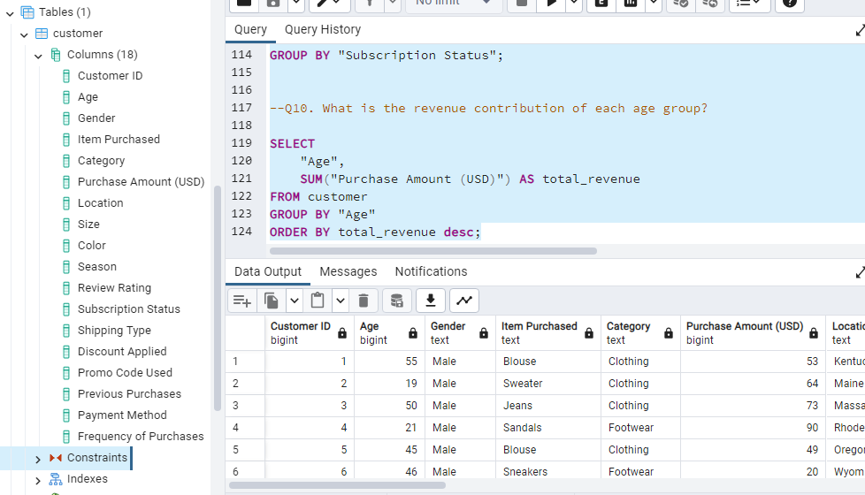

--Q1. What is the total revenue generated by male vs. female customers?
SELECT
"Gender",
SUM("Purchase Amount (USD)") AS revenue
FROM customer
GROUP BY "Gender";

--Q2. Which customers used a discount but still spent more than the average purchase amount?
SELECT
"Customer ID",
"Purchase Amount (USD)"
FROM customer
WHERE "Discount Applied" = 'Yes'
AND "Purchase Amount (USD)" > (
SELECT AVG("Purchase Amount (USD)")
FROM customer
);

-- Q3. Which are the top 5 products with the highest average review rating?
SELECT
"Item Purchased",
ROUND(AVG("Review Rating"::numeric), 2) AS "Average Product Rating"
FROM customer
GROUP BY "Item Purchased"
ORDER BY AVG("Review Rating"::numeric) DESC
LIMIT 5;

--Q4. Compare the average Purchase Amounts between Standard and Express Shipping.
SELECT
"Shipping Type",
ROUND(AVG("Purchase Amount (USD)")::numeric, 2) AS avg_purchase_amount
FROM customer
WHERE "Shipping Type" IN ('Standard', 'Express')
GROUP BY "Shipping Type";

--Q5. Do subscribed customers spend more? Compare average spend and total revenue between subscribers and non-subscribers.
SELECT
"Subscription Status",
COUNT("Customer ID") AS total_customers,
ROUND(AVG("Purchase Amount (USD)")::numeric, 2) AS avg_spend,
ROUND(SUM("Purchase Amount (USD)")::numeric, 2) AS total_revenue
FROM customer
GROUP BY "Subscription Status"
ORDER BY total_revenue DESC, avg_spend DESC;

--Q6. Which 5 products have the highest percentage of purchases with discounts applied?
SELECT
"Item Purchased",
ROUND(
100.0 * SUM(CASE WHEN "Discount Applied" = 'Yes' THEN 1 ELSE 0 END)
/ COUNT(*), 2
) AS discount_rate
FROM customer
GROUP BY "Item Purchased"
ORDER BY discount_rate DESC
LIMIT 5;

--Q7. Segment customers into New, Returning, and Loyal based on their total number of previous purchases, and show the count of each segment.
WITH customer_type AS (
SELECT
"Customer ID",
"Previous Purchases",
CASE
WHEN "Previous Purchases" = 1 THEN 'New'
WHEN "Previous Purchases" BETWEEN 2 AND 10 THEN 'Returning'
ELSE 'Loyal'
END AS customer_segment
FROM customer
)
SELECT
customer_segment,
COUNT(*) AS "Number of Customers"
FROM customer_type
GROUP BY customer_segment;

--Q8. What are the top 3 most purchased products within each category?
WITH item_counts AS (
SELECT
"Category",
"Item Purchased",
COUNT("Customer ID") AS total_orders,
ROW_NUMBER() OVER (
PARTITION BY "Category"
ORDER BY COUNT("Customer ID") DESC
) AS item_rank
FROM customer
GROUP BY "Category", "Item Purchased"
)
SELECT
item_rank,
"Category",
"Item Purchased",
total_orders
FROM item_counts
WHERE item_rank <= 3;

--Q9. Are customers who are repeat buyers (more than 5 previous purchases) also likely to subscribe?
SELECT
"Subscription Status",
COUNT("Customer ID") AS repeat_buyers
FROM customer
WHERE "Previous Purchases" > 5
GROUP BY "Subscription Status";

--Q10. What is the revenue contribution of each age group?
SELECT
"Age",
SUM("Purchase Amount (USD)") AS total_revenue
FROM customer
GROUP BY "Age"
ORDER BY total_revenue desc;

